

**Reka Bentuk Antara Muka Berasaskan Web**

**(CSF3133)**

**LAB REPORT 2**

NAME: CHIA FU YAN

MATRIC: S75039

DATE: 29/10/2024

GROUP: K4

PROGRAM: Computer Science (Software Engineering)

**2.3 Working with Tables**

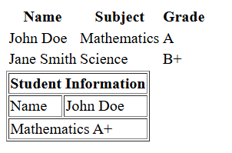

**2.4 Creating Forms**

**2.4.1 Basic Form Elements**

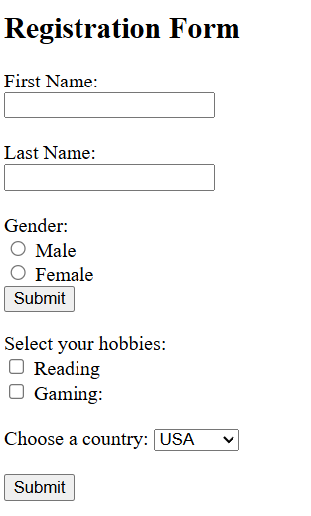

**2.4.2 Other Form Elements**



**2.5 Semantic HTML**

**2.5.1 Common Semantic Tags**

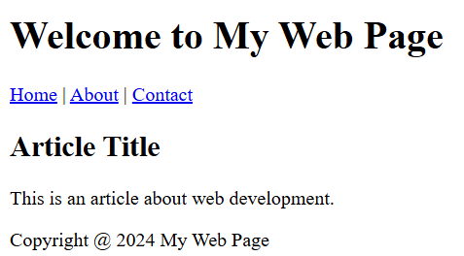

**2.6 Lab Exercise 2**

**Source Code**

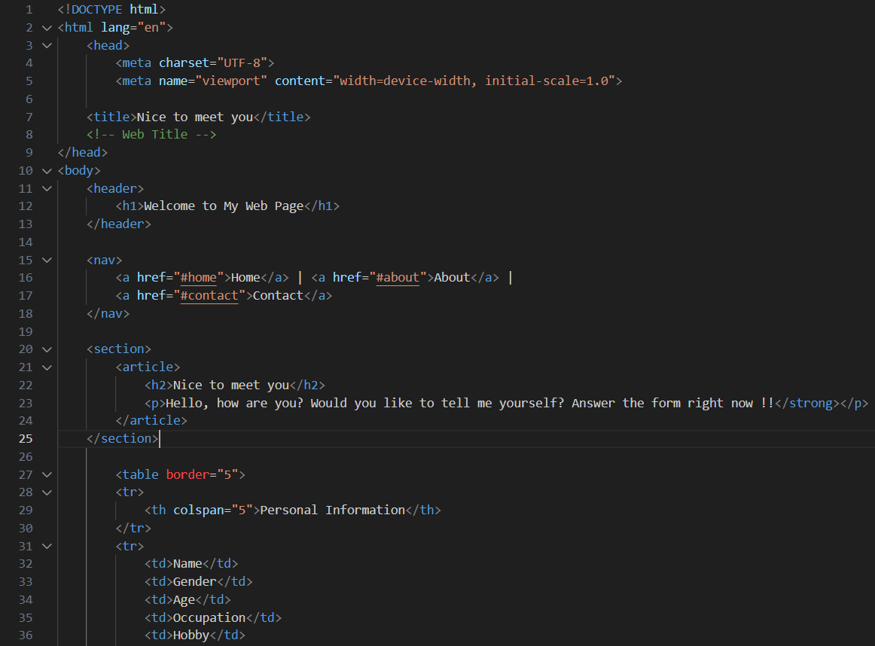

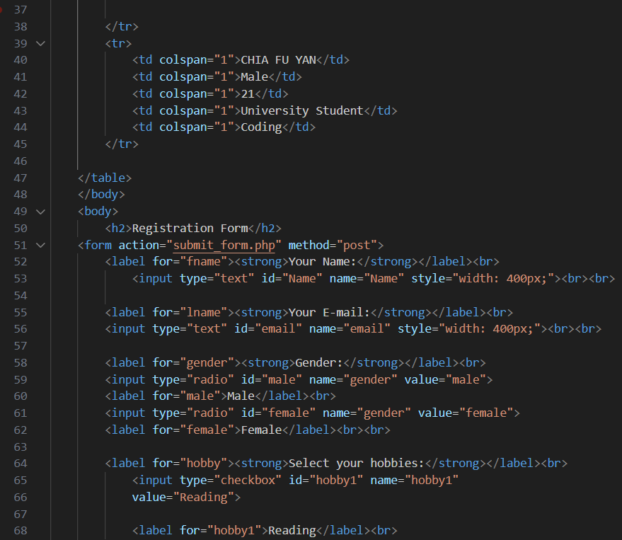

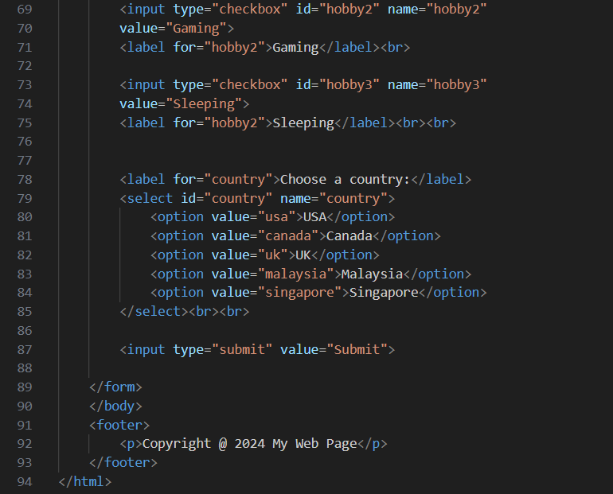

**Output**

